SEND in Suffolk

Scheme of delegation in respect of decisions relating to Education, Health & Care (EHC) Needs Assessments and EHC plans

Version details
- Version: 1.0
- Last updated:
- Updated by: Wendy Allen, Francesca Alexander & Ros Somerville
- Date for review: To be reviewed annually, with next review in March 2023
- Responsibility to review:

Introduction and principles

The purpose of this document
The scheme of delegation is a decision-making framework which sets out the delegated powers related to SEND and/or allocation of additional resources. It empowers officers of the Council to take decisions on behalf of the Director of Children Services to ensure that the Council meets its obligations under the Children and Families Act 2014, SEND Code of Practice 2015 and relevant financial regulations.
All decisions should be well informed, transparent and must have regard to the views and wishes of parents/carers, young people and professional advice. Reasons for decisions must be clearly recorded and communicated, they must ensure fair and transparent distribution of resources. Decisions are subject to routine audits and council corporate procedure.

Principles
Our vision for SEND in Suffolk can be found in the SEND Strategy
Ensuring that decision-making, planning and support for children and young people with SEND in Suffolk is the individual and collective responsibility of all professionals, managers and leaders across education, health, and care services.

Key documents
All officers making decisions about EHC needs assessments and plans in Suffolk must have regard to the following national guidance and legislation –
- Children and Families Act 2014 and its associated regulations;
- SEND Code of Practice 2014 (subsequent changes and amendments January 2015);
- Children's Act 1989;
- Chronically Sick and Disabled Persons Act 1970;
- Working Together to Safeguard Children and Keeping Children Safe in Education;
- School Admissions Code of Practice;
- Equality Act 2010;
- Supporting pupils at school with medical conditions;
- Mental Capacity Act 2005;
- Care Act 2014; and
- The School and Early Years Finance (England) Regulations.
All officers making decisions about EHC needs assessments and plans in Suffolk must also have regard to the following local guidance, which sets out the practices and processes that must be consistent across the SEND system in Suffolk –
- Terms of reference for SEND panels
- Suffolk SEND strategy.;
- Suffolk banding framework.;
- Suffolk EHCP quality-assurance framework.; and
- Suffolk EHCP annual review guidance

A summary of where authority for making decisions about aspects of the EHC system sits within Suffolk

Summary
This scheme of delegation was developed through consultation with a working group of senior leaders responsible for SEND in the local authority and engagement with a wider core group of representatives from Education, Social Care and Health in 2021. In planning where decision-making authority should sit within Suffolk. This is summarised in the graphic below.
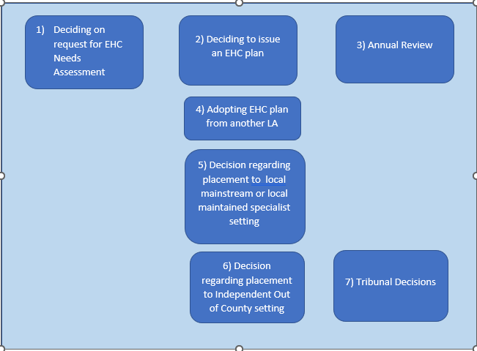

The table below presents an “at-a-glance” summary of where responsibilities for each of these stages sit within the Suffolk system.
Stage of EHC process | Assistant Coordinators | Co-ordinator | Family Service Leads | SEND Service Managers | Head of Service | County EHCNA Panel | Area EHCP Panel | County Independent Placement Panel
- Request for EHCNA |  |  |  | X | X | X
- Decision to issue EHC plan |  |  |  | X | X |  | X
- Annual Review  … initial triage, no change to placement type | X | X | X | X | X
…change of placement, type remains the same |  |  | X | X | X
… change of placement type |  |  |  | X | X |  | X
…..cease EHC plan |  |  |  | X | X |  | X
- Adopting EHCPs from other areas  Straightforward/direct equivalent |  |  | X | X | X
… no direct equivalent in Suffolk |  |  |  | X | X |  | X
- Requests for independent/out of county sector placements | County Independent Placement Panel |  |  |  |  |  |  |  | X
- Tribunal decisions | Head of Service, Family Service Manager to be ratified at appropriate panel |  |  |  |  |  |  |  | X

Delegation of decision-making responsibilities

In detail
Officer (and Panel where decisions taken through a Panel chaired by the Officer) | Frequency of decision-making | Level of decision-making | Recording and communication of decisions | Escalation, review or QA of decision-making
Assistant Coordinators and Coordinators | Ongoing (to meet statutory timescales) | Requests for statutory assessment  To co-ordinate the EHC needs assessments.  To make a recommendation as to whether information provided is complete enough to be presented at Education Health & Care Needs Assessment Panel  New EHCPs  To prepare Needs Assessment Reports.  To prepare draft EHCPs.  To make a recommendation as to whether information provided is complete enough to be presented at Area EHCP Panel  Existing EHCPs  To consider annual review reports from settings, schools and colleges.  Where there is “no change” recommended, to decide whether to agree with that recommendation.  To agree to amendments that would not require any changes in the allocation of resources – for example, updating the EHCP so that it accurately reflects the young person’s assessed needs, required provision, targets and outcomes.  Where the recommendation from the setting / school or the judgement of the Family Services Lead Coordinator themselves is that a more significant change to the EHCP is required or the EHCP may need to be ceased, to refer those cases to the chair of the Area EHCP Panel.  To hold annual reviews for children and young people who are being electively home educated. (Coordinators only) | To maintain up to date notes and records of decisions reached and reasons for decisions.  To communicate decisions taken regarding requests for assessments, issuing new EHCPs, and annual reviews to parents / carers, young people, and settings / schools / colleges as appropriate, verbal communication to be followed up in writing and in a timely manner.  To alert Lead Coordinators to potential risks of placement breakdown, escalation of costs, appeals against decisions. | Requests to review decisions should be escalated to the Family Services Lead Coordinator for supervision and oversight.
Family Services Lead Coordinator | Weekly (Panel meetings on a rotational basis)  Other decisions as required | Requests for statutory assessments  To review any decisions taken or being considered by the Family Service Assistant Coordinators and Coordinators that have been raised through the escalation process.  New EHCPs & Existing EHCPs  To consider requests for changes to EHCPs through the annual review process where the changes requested are of a change of placement type (e.g., a change from a mainstream school to a special school).  Requests for placements in independent provision must be referred to the Head of SEND and considered through the County Independent Placements Panel.  To consider the content of EHCPs of young people who have moved from another local area, which previously maintained the EHCP, and to agree to the most appropriate provision, or further assessment, if there is not a straightforward or direct equivalent in Suffolk. | To ensure that records of decisions reached and reasons for decisions are recorded accurately, appropriately and in a timely manner.  To alert Family Services Managers to potential risks of placement breakdown, escalation of costs, appeals against decisions. | Requests to review decisions should be escalated to the SEND Operational Manager or the Head of SEND for supervision and oversight.
SEND Services Managers | Weekly/Monthly panel and As required | New and existing EHCPs  As chair of the Area EHCP Panel, to consider and decide whether to agree to requests to issue an EHCP,  As chair of the County EHC Needs Assessment Panel, to consider requests for EHC needs assessments or re-assessments, in line with the Code of Practice and Suffolk EHCNA Guidance document  New and existing EHCPs  As chair of the Area EHCP Panel, to consider and decide whether to agree to requests to issue an EHCP, cease an EHCP, to change placement type and adopt EHCP from out of county as required.  To agree medical needs in consultation with the Designated Clinical Officer from the relevant ICB.  To agree suitability of placement with local specialist provision.  To act as the representative of SEND at joint-agency panels considering joint provision and funding for placements for children with EHCPs requiring input from education, health, and care. | To ensure that records of decisions reached and reasons for decisions are recorded accurately, appropriately and in a timely manner.  To alert SEND Operational Manager and/or Head of Service to potential risks of placement breakdown, escalation of costs, appeals against decisions. | Requests to review decisions should be escalated to the Head of SEND.  As chair of the Area EHCP Panel, to refer cases where independent provision may be required to the chair of the County Independent Placement Panel
Head of SEND | Fortnightly panel and as required | As chair of the County Independent Placement Panel to consider any requests for an independent and/or non Suffolk education placement and associated funding. | Actions, recommendations to be recorded as part of the coordinator function for panels | To Assistant Director of Inclusion required
SEND Manager (Tribunals)/Resolutions & Tribunal Officer | As required. | To take decisions in Tribunal hearings or in implementing Tribunal judgements, when decisions are required at that time and cannot be deferred to Panel discussions. | To communicate decisions made at tribunal to EHCP Area Panel for noting  To communicate decisions to appropriate Family Services staff member to action tribunal decision | Final Tribunal judgements must be implemented by the local authority.

Arrangements and responsibility for reviewing the scheme of delegation
This scheme of delegation will be reviewed and, if necessary, updated annually. Feedback will be gathered from the officers listed in the preceding section, through Panel meetings, and through the operation of the Suffolk EHCP Quality-Assurance Framework. Responsibility for the review of the scheme of delegation and enacting decisions by the Director of Children’s Services and the Director of Education regarding any changes made to the scheme of delegation will sit with the Head of SEND Strategy & Innovation.

