Education, Health and Care (EHC) Plan Review
Family/ Carer’s Views Form

An Education, Health and Care (EHC) plan must be reviewed at least annually.
The purpose of a review is to consider if the contents of a child/ young person’s Education, Health and Care (EHC) plan are relevant or need to change to help them make progress towards outcomes and longer-term aspirations set out within their plan.
This Family/ Carer Views form template supports the capturing of parents/ carers/ families’ contribution to the Education, Health and Care (EHC) plan review, including what is working well and what is not working so well, in advance of the meeting.
Those completing this form may wish to speak to others who care for the child/ young person and complete this form collectively, or complete separate forms.

- This Family/ Carer Views form should be shared with you at least 6-8 weeks before the scheduled Education, Health and Care (EHC) plan review meeting for completion.
- The completed Family/ Carer Views form will then be shared with everyone attending the meeting at least 2 weeks before the scheduled Education, Health and Care (EHC) plan review meeting.
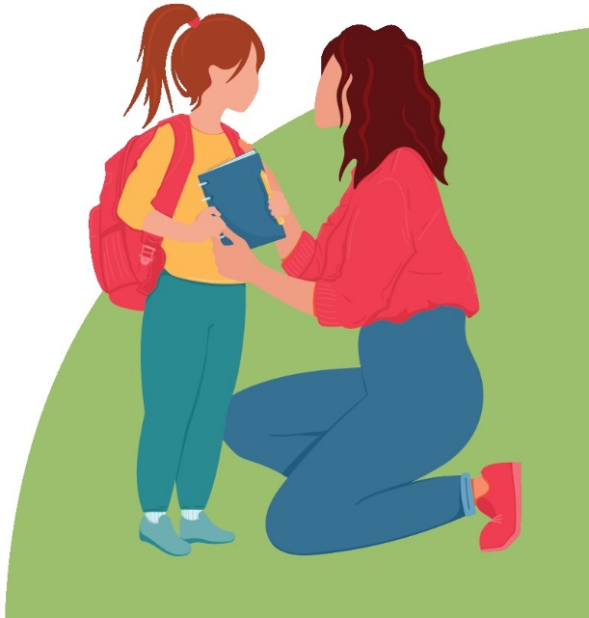
- The completed form will form part of the discussions at the meeting and will be attached to the Education, Health and Care (EHC) plan review report by the education setting. The review report, which will include recommendations from the meeting, must be shared by the education setting with the Local Authority (LA) and invitees and attendees of the meeting within 2 weeks of the date of the meeting.

Further information about the EHCP Review process can be found on the Suffolk Local Offer website: Annual Reviews - Suffolk SEND Local Offer (suffolklocaloffer.org.uk)
The Suffolk Local Offer website includes links to other templates to capture the views of children and young people as part of the EHCP Review process. This includes the Child Views form, and Preparing for Adulthood Plan (required to be completed for young people in year 9 and above, please also see the transitions guide for further information).

SENDIASS provides impartial information, advice and support for children, young people and their families, including about approaches to person-centred planning; Person-centred planning - Suffolk SENDIASS.

Please note that fields indicated with * are mandatory.
If a family/ carer views form has been previously completed, and there has been no change to the demographic or contact information below, you do not need to complete these fields. However, if there has been a change, please complete the relevant fields to update this information.

Child/ Young Person:
Legal Surname*: |  | Legal first name(s)*:
Preferred Surname: |  | Preferred first name(s):
Home address:
Gender: |  | Date of birth*:
Religion: |  | Home language:
Education setting*:
National Curriculum Year:
Contact Details if young person is 16+ (please also detail preference for use):

Person(s) completing this Family/ Carer Views form:
You can include the details of more than 1 person providing views.
You may wish to include the views of people living in the household / those that have regular contact with the child/ young person.
1 | Surname*: |  | First name(s)*:
 | Home address Home address* (if different to the above):
 | Email address*:
 | Telephone no*: |  | Relationship to child/ young person*:

Do you have parental responsibility for the child/ young person?*
Yes ☐ No ☐
1 | Surname: |  | First name(s):
 | Home address Home address (if different to the above):
 | Email address:
 | Telephone no: |  | Relationship to child/ young person:

Do you have parental responsibility for the child/ young person?
Yes ☐ No ☐

Have you included the views of any others in this form?
If so, please detail below.

If the person(s) providing Family/ Carer Views do not hold parental responsibility for the child/ young person, please include the contact details for the individual with parental responsibility below.
Parental Responsibility Contact:
1 | Surname: |  | First name(s):
 | Home address Home address (if different to the above):
 | Email address:
 | Telephone no: |  | Relationship to child/ young person:

What do you like and admire about your child/ young person?

Which of their achievements over the last year are you most proud of?

What is important to and for your child/ young person now and in the future?

Is the support provided by the EHCP helping your child/ young person make progress?
Yes, a lot ☐ Yes, a little ☐ No ☐ Don’t know ☐

Comments:

What is working well with regard to education? | What is working well at home/ outside of education?

What is not working well for your child or young person with regard to education? | What is not working well for your child or young person at home/ outside of education?

Looking forward, what are your hopes, dreams and ambitions for your child or young person for the next year and longer term?

Any other comments?


Date completed: _________________

